# **XJ-Series**

Jaguar XJ-Series suspension systems will provide an excellent ride experience for the first 3-5 years after the vehicle leaves the factory. Slowly over time many of the rubber components will start deteriorating. This slow degradation of the rubber components in Struts, Shocks, Mounts & Bushings will cause small, sometimes barely visible cracks or pinholes that will cause gas or oil in the system to slowly escape. When there is a gas or oil leak in your Jaguar XJ-Series suspension system, it can cause other components to overwork and fail. When Jaguar XJ-Series struts or shocks fail, your Jaguar XJ-Series is nearly impossible to drive. BAVARIA CENTER provides many solutions for your suspension repair. We offer many Aftermarket Parts, New or Remanufactured, including Struts, Shocks, Mounts, Bushings, Height Sensors and more. Our friendly staff is available to assist you and your satisfaction is our guarantee! You may contact us for any questions or recommendations. We are here to help your Jaguar XJ-Series get back on the road!

# **XJ (X350) 2003-2009**

# **Jaguar XJ Series (X350) Air Spring Strut Air Suspension front**

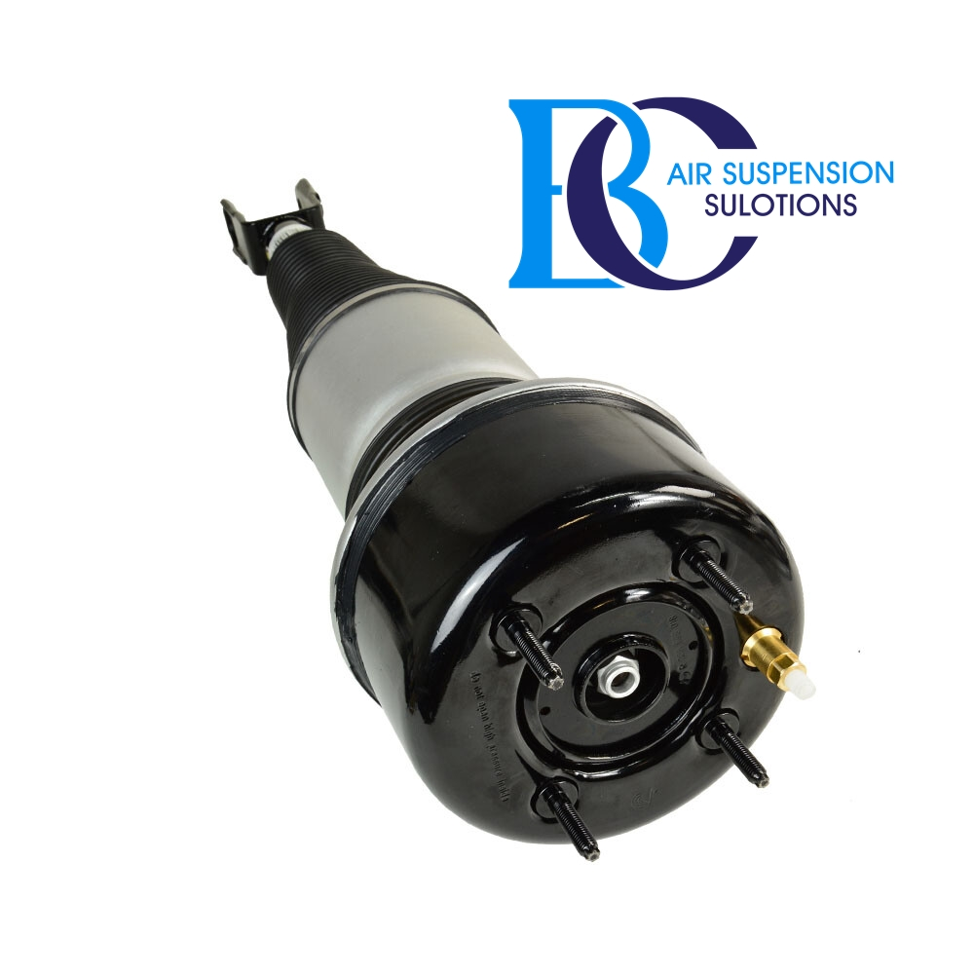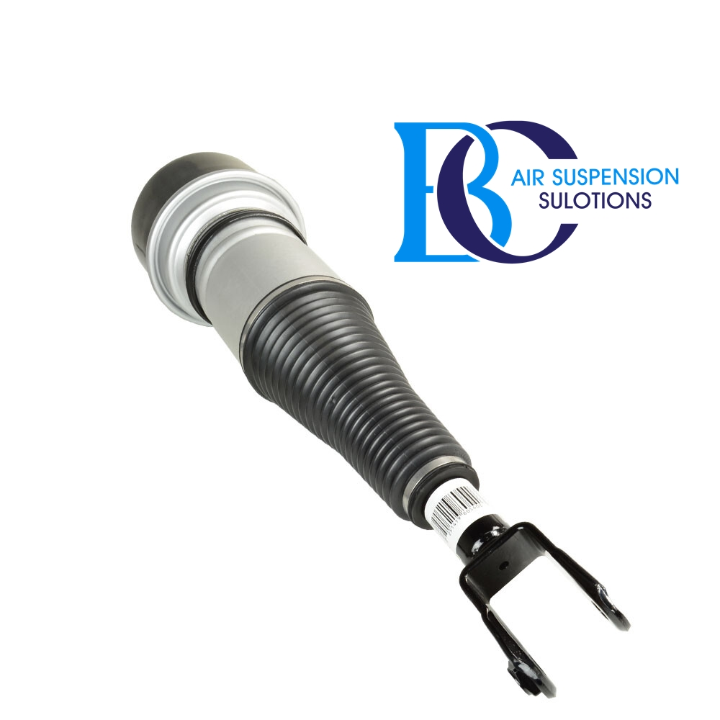

**Description**

This is the front shock absorber of the air suspension for the Jaguar XJ series (X350).

- Active inner valve in the shock absorber.

This means that this shock absorber reacts actively to the driving comfort you choose.

You get an air suspension damper with CDC damping function (continuous damping control).

Hydraulic shock absorber, with internal valve.

**Can be installed in the following vehicles:**

Jaguar XJ Series (X350, X358) 2003-2010

**OEM part number:**

C2C41349, C2C41347, C2C41339, C2C28533, C2C28409, C2C25696.

# **Jaguar XJ Series (X350) Air Spring Strut Air Suspension rear**

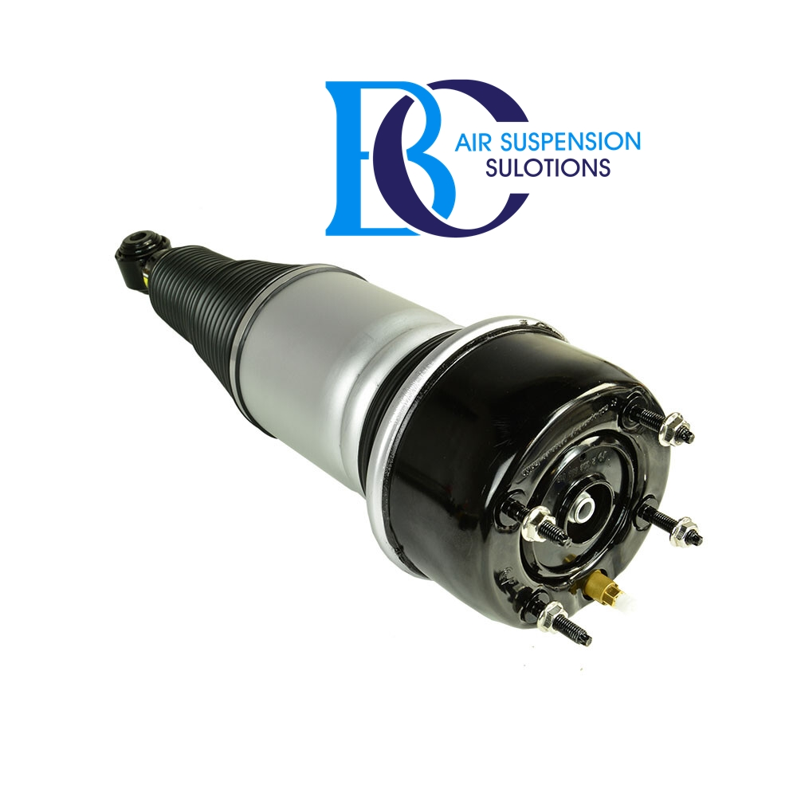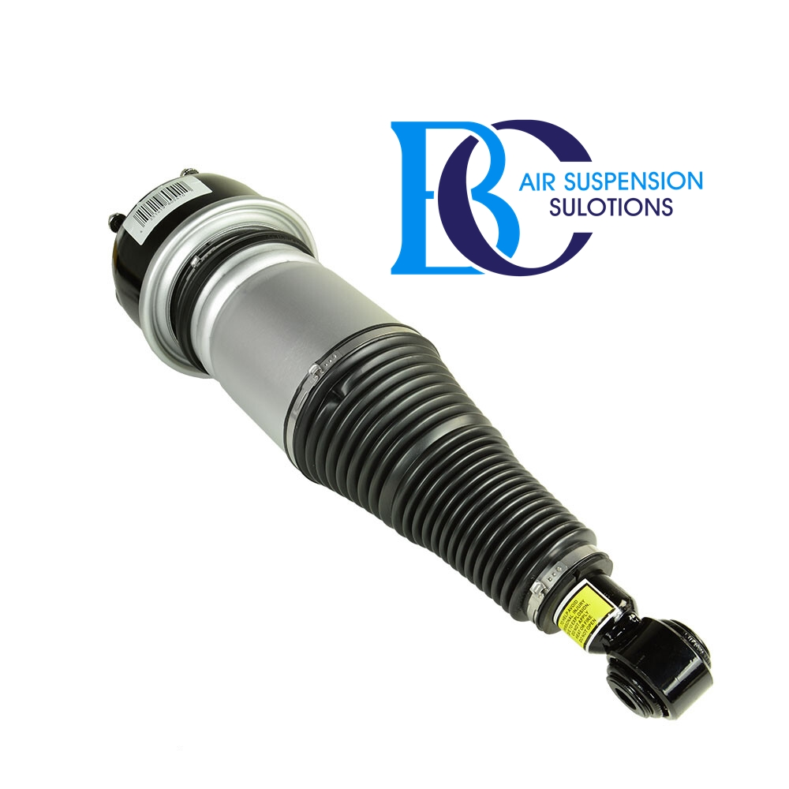

**Description**

This is the rear shock of the air suspension for the Jaguar XJ series (X350).

Active inner valve in the shock absorber.

This means that this shock absorber reacts actively to the driving comfort you choose.

You get an air suspension damper with CDC damping function (continuous damping control).

Hydraulic shock absorber, with internal valve.

**Can be installed in the following vehicles:**

Jaguar XJ Series (X350, X358) 2003-2010

**OEM part number:**

C2C41341, C2C41343, C2C28531, C2C28407, C2C24410, C2C25694

# **Jaguar XJ (X350) Compressor air suspension**

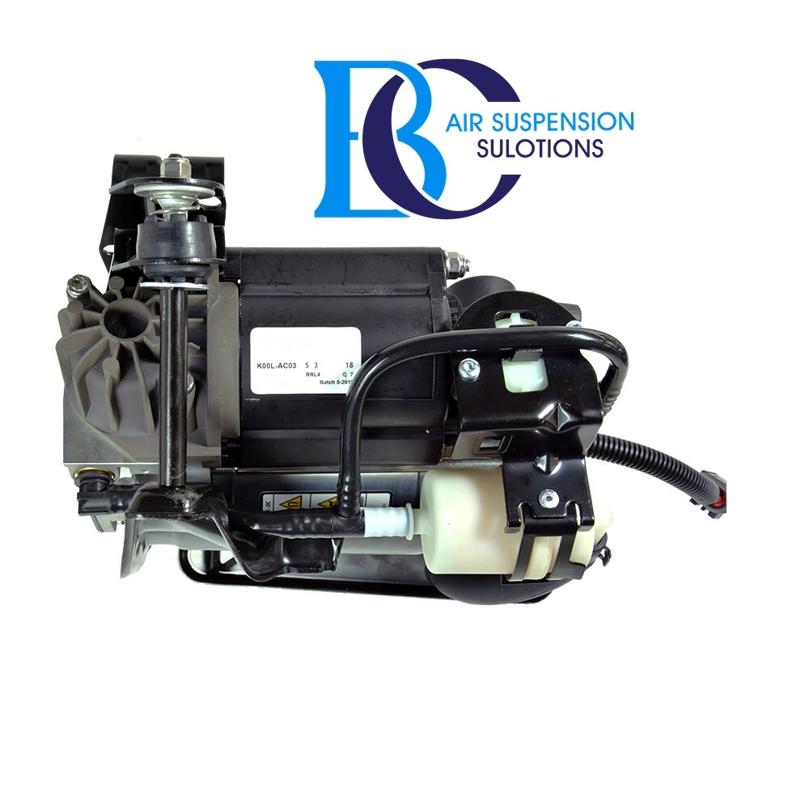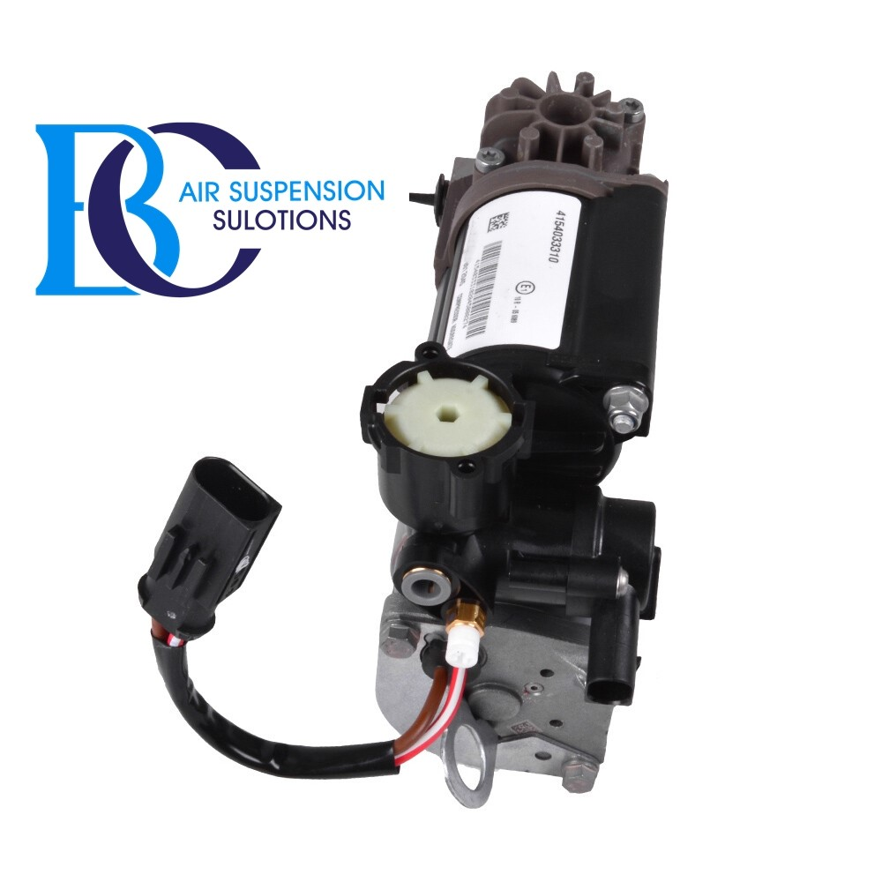

**Description**

This is a compressor unit for the air suspension of the Jaguar XJ (X350).

**Can be installed in the following vehicles:**

Jaguar XJ8 Base (2004-2009)

Jaguar XJR Base (2004-2009)

**OEM part number:**

C2C2450 ; C2C22825 ; C2C27702E ; C2C27702

# **Jaguar XJ (X350) Valve block air suspension**

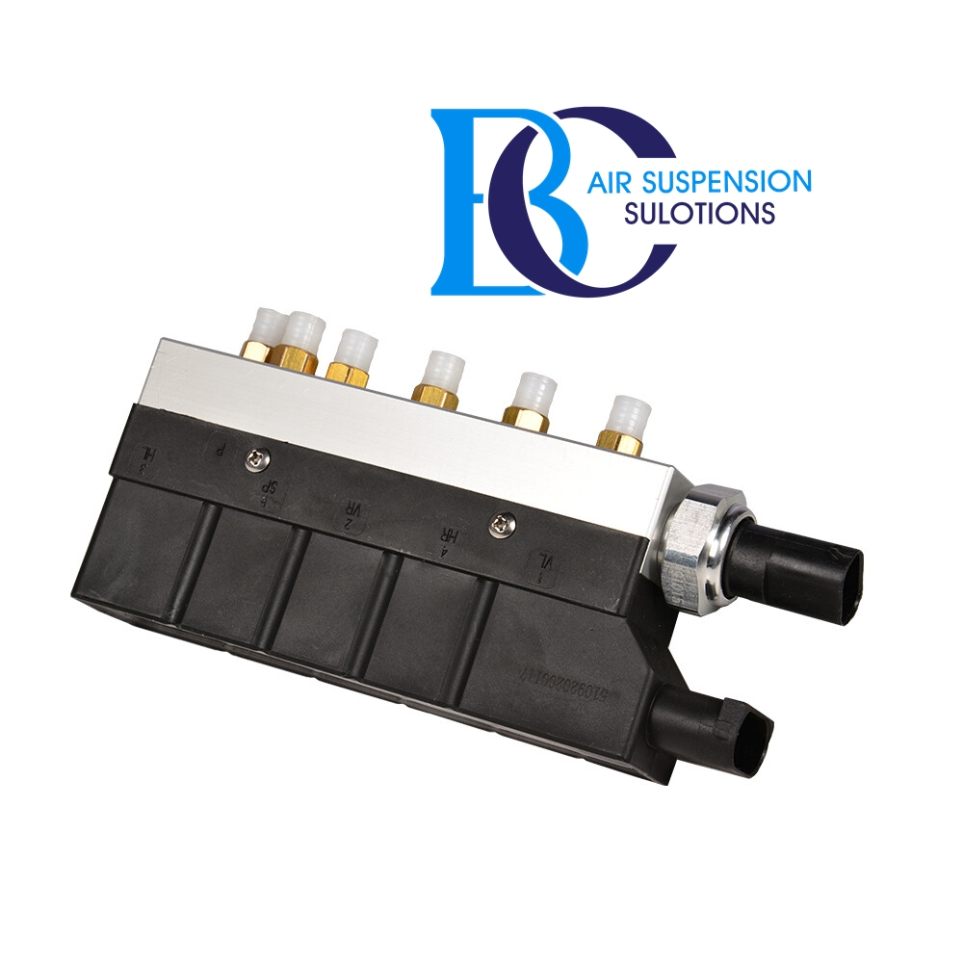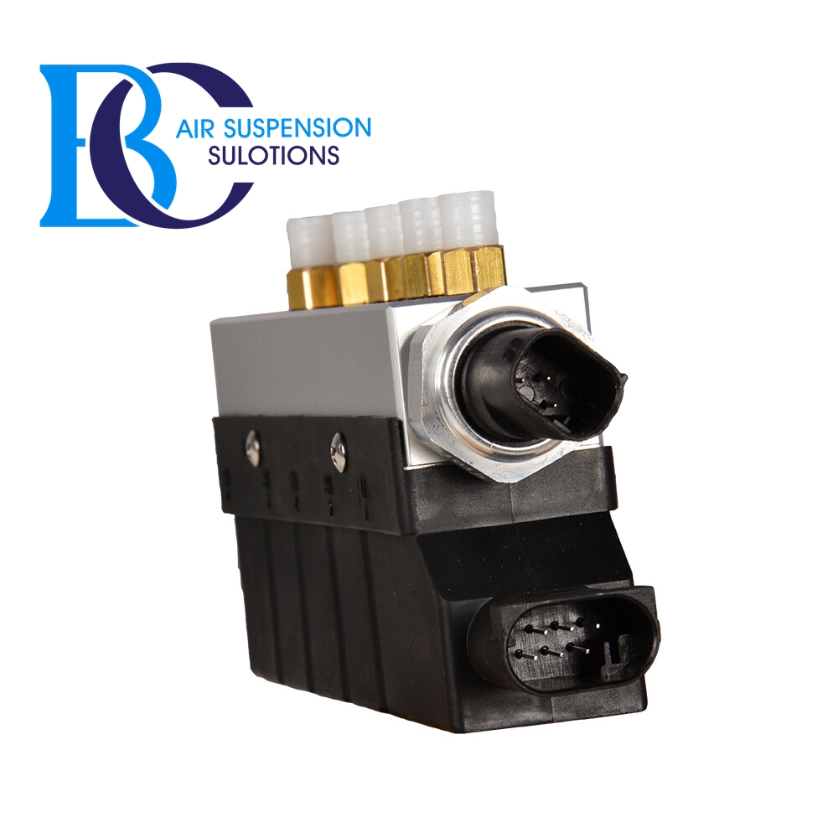

**Description**

This is a valve for the air suspension of the Jaguar XJ (X350).

**Can be installed in the following vehicles:**

Jaguar XJ8, XJ8 L, XJR (X350; X358) 2003-2010

**OEM part number:**

C2C2241

# **2. - XJ (X351) 2010-2019**

# **Jaguar XJ Series (X351) Air Spring Strut Air Suspension rear**

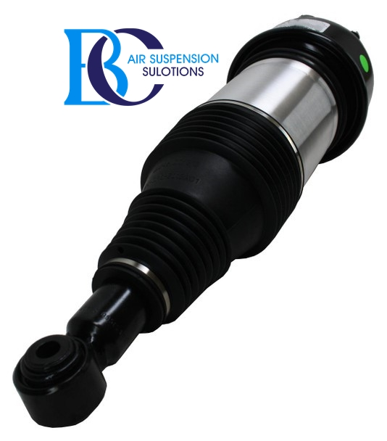DD

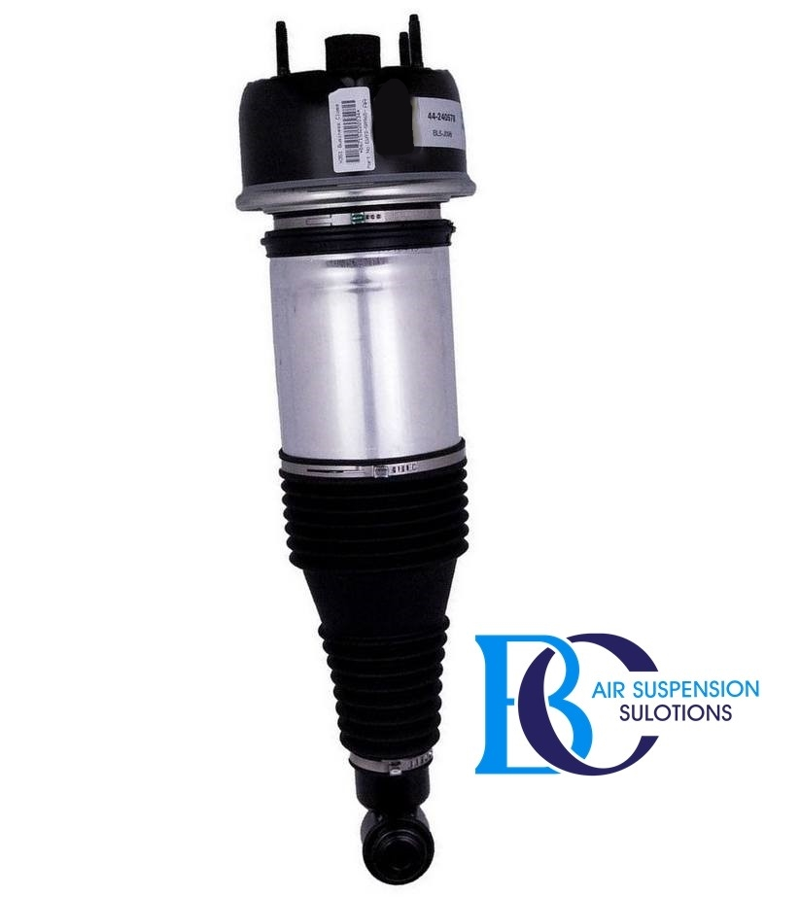

**Description**

This is the rear shock of the air suspension for the Jaguar XJ series (X351).

Active inner valve in the shock absorber.

This means that this shock absorber reacts actively to the driving comfort you choose.

You get an air suspension damper with CDC damping function (continuous damping control).

Hydraulic shock absorber, with internal valve.

**Can be installed in the following vehicles:**

Jaguar XJ Series (X351) 2010-2019

**OEM part number:**

C2D33847

# **Jaguar XJ Series (X351) Compressor air suspension**

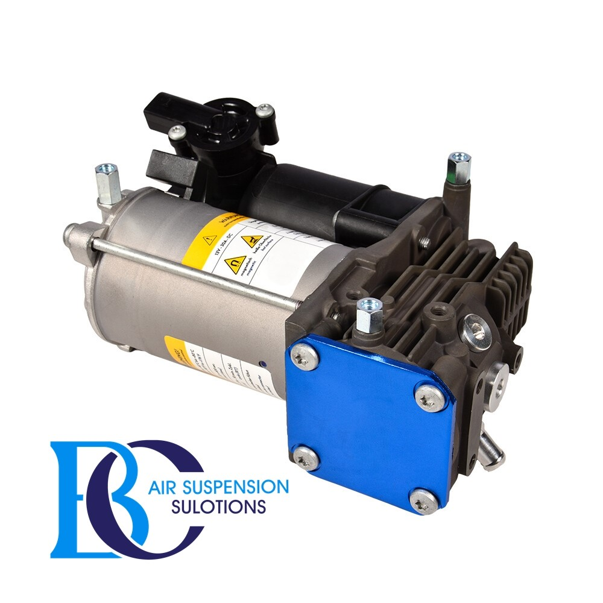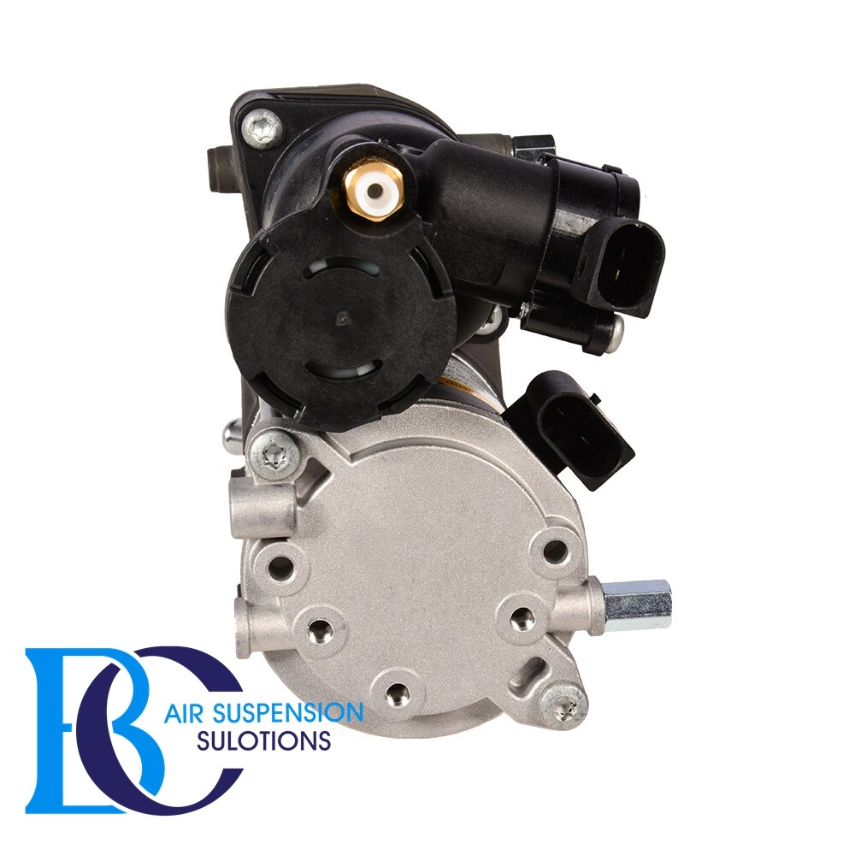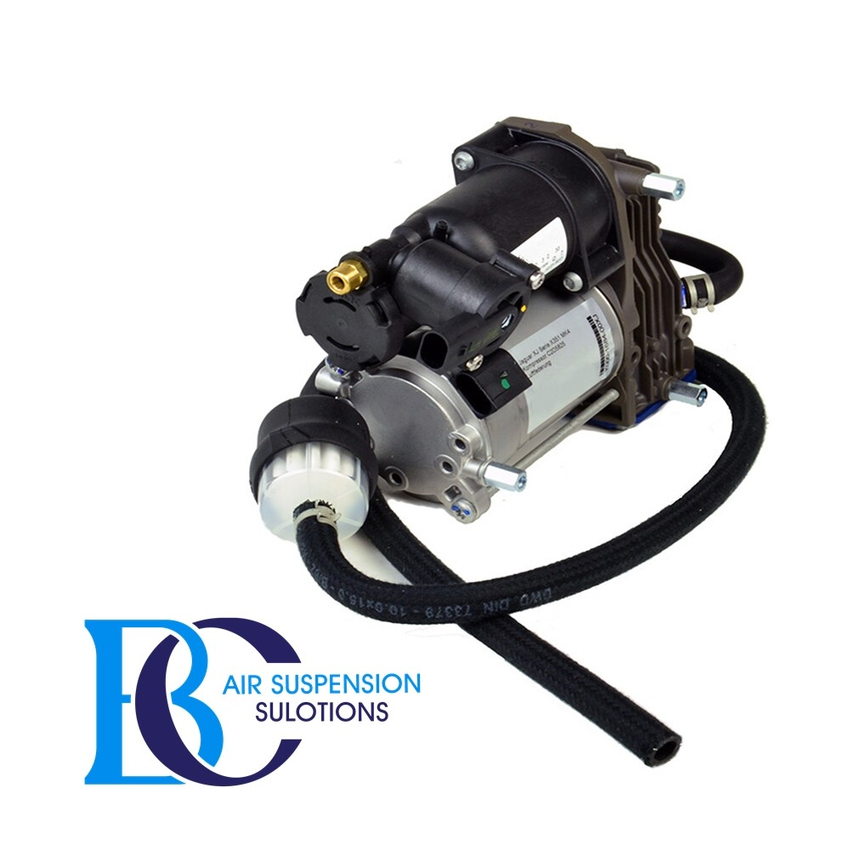

**Description**

This is compressor air suspension for the Jaguar XJ series (X351).

**Can be installed in the following vehicles:**

Jaguar XJ-Series X351 (XJ, XJR, XJR575) 2009--

**OEM part number:**

C2D42519, C2D31933, C2D5825, C2D26813, C2D31933.

# **Jaguar XJ-Series X351 Valve block air suspension**

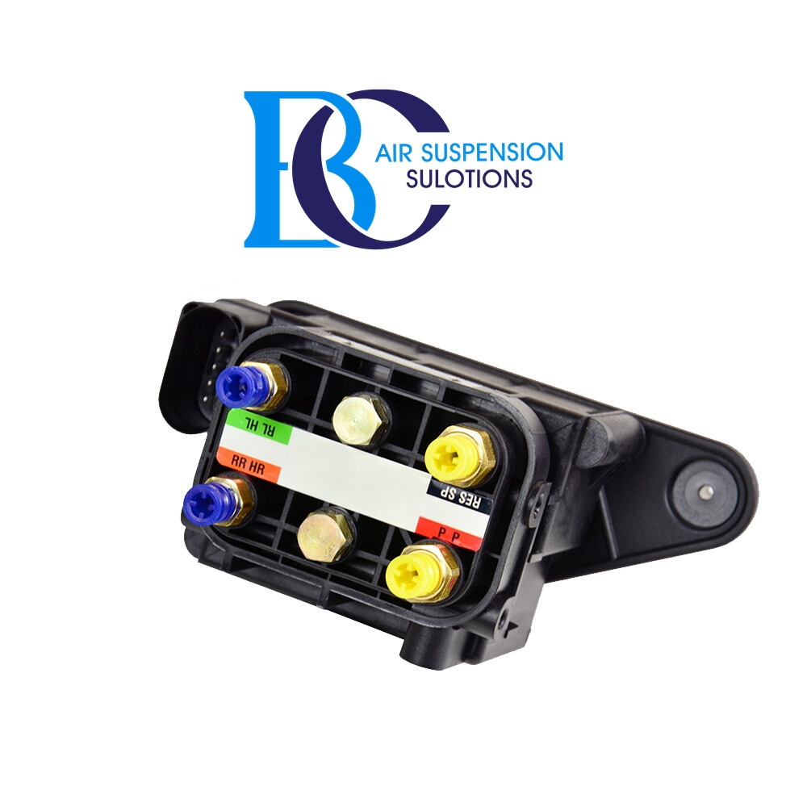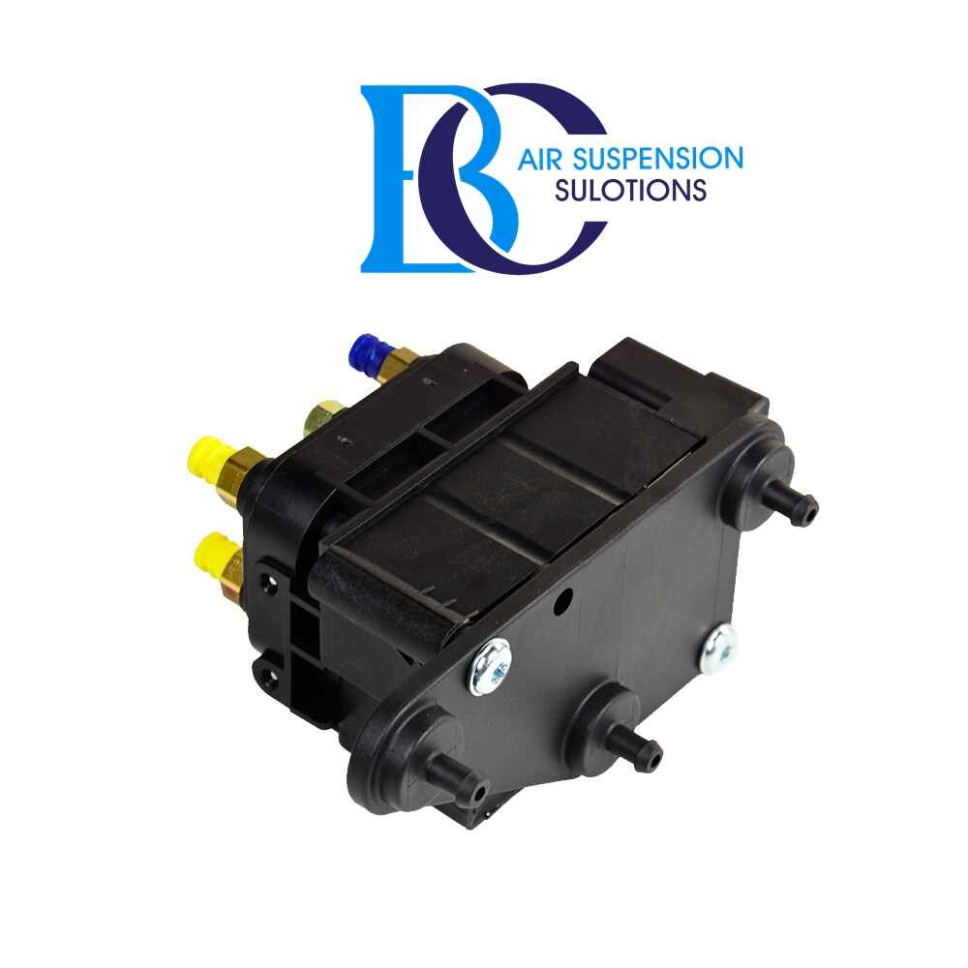

**Description**

This valve for the compressor unit of the air suspension of the Jaguar XJ-Series X351.

**Can be installed in the following vehicles with air suspension / Airmatic:**

Jaguar XJ-Series X351 (XJ, XJR, XJR575) 2009--

**OEM part numbers:**

C2D26814, C2D10526.